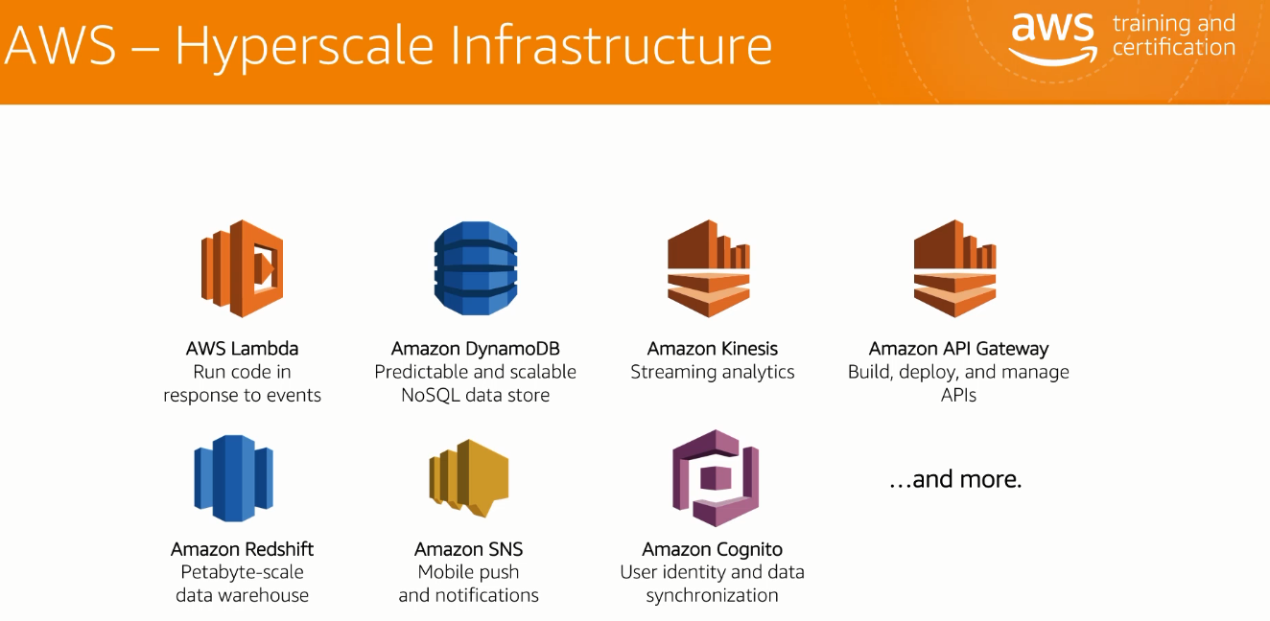

AWS Lambda: Run the code in response events.

Amazon DynamoDB: It is the database for the data collected.

Amazon Kenesis: Analytics tool that performs analysis on the data collected.

Amazon API gateway: In order to manage (Build,deploy,manage) all the diff API’s

Amazon Redshift:

Amazon SNS: Notification push tool, kind of a reminder.

Amazon Cognito: kind of ADFS. Active directory.

**IoT Foundation Telemetry:**

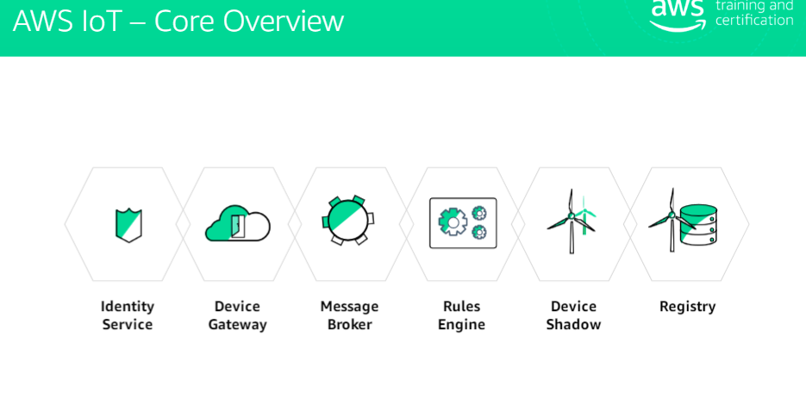

**Q) Our Scenario:**

**There is an Ice cream company and the ice cream company is facing loss due to ice creams getting melted, Hence give them a solution with IoT.?**

Some things that can be tracked with IoT:

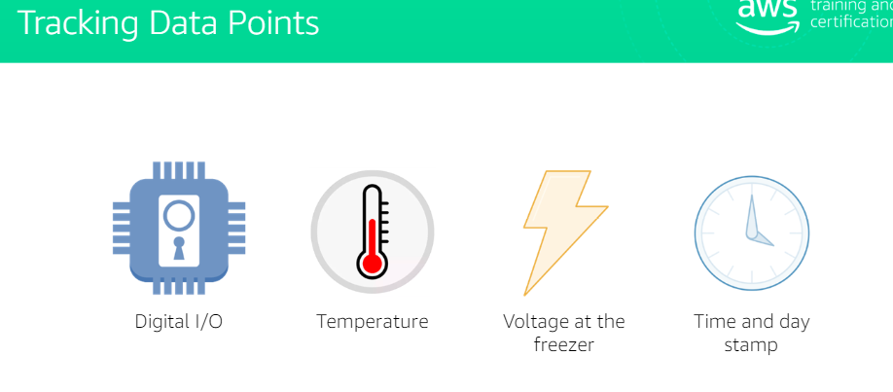

*Digital I/O: It represents the freezer doors of the trucks as they are automatic doors.

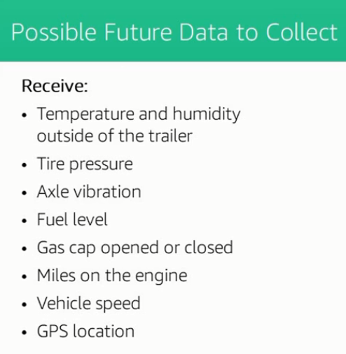

*Above are a few other possible data that can be collected to analyze the problem.

**2) Implementing Things and Devices**

Things and devices are 2 different things, Things can be appliances(Lightbulbs,Thermostats) which have a unique attribute or attributes. Example below:

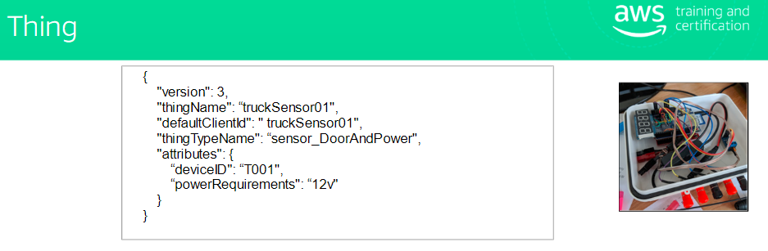

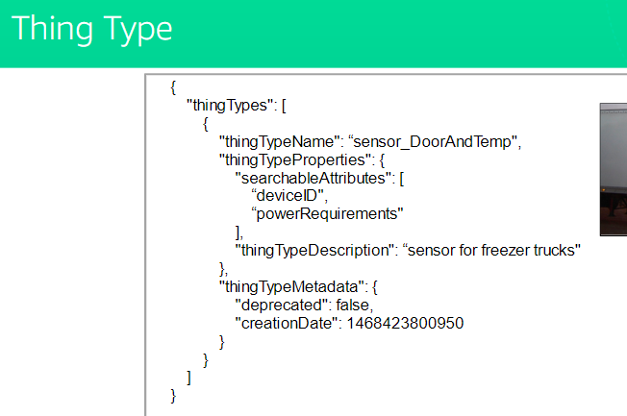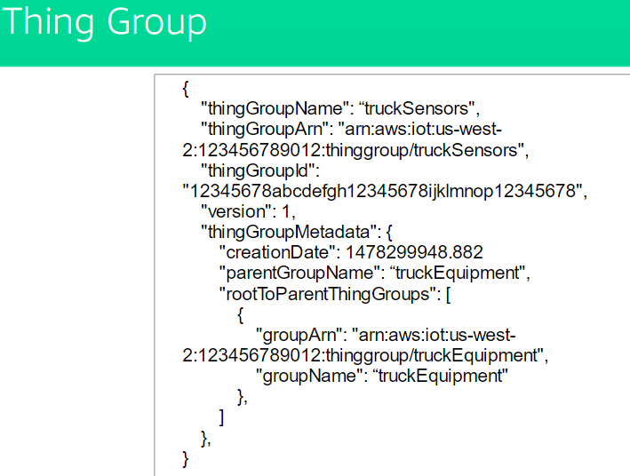

\***Creating a Thing**:

Log into AWS account-services->IoT core->click Onboard->Configure a Device->GetStarted

Below page is displayed.

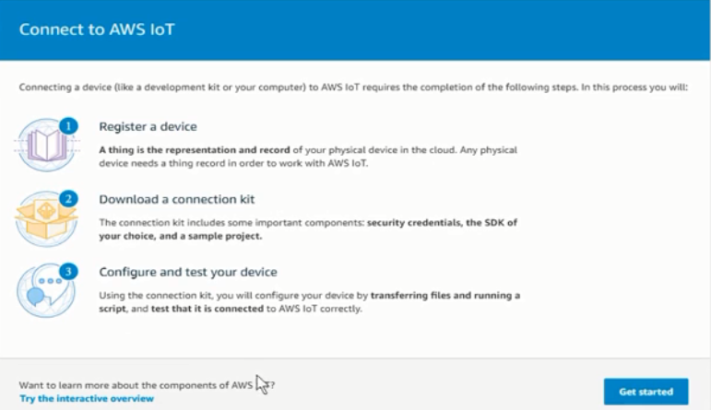

After This

1)Select Platform/DeviceSDK(as Required).

2)Give Thing Name, Thing Type and specify attribute so that you can search this thing later in the registry.(if needed)

3)Download connection kit and test your thing, Finally below page indicates it is finished.

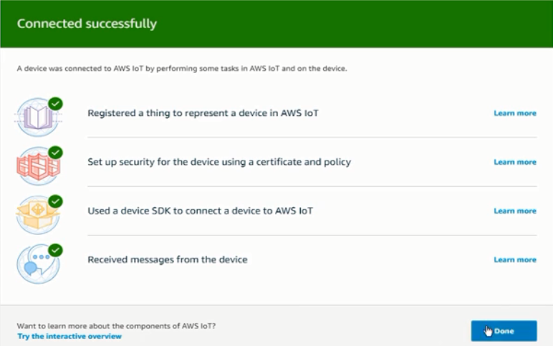

**Securing the Devices**:

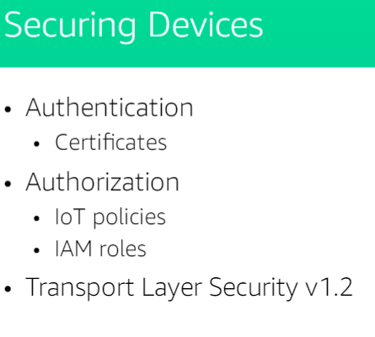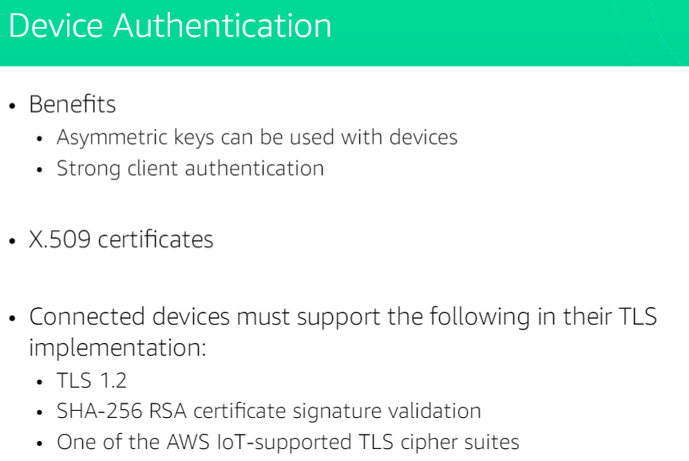

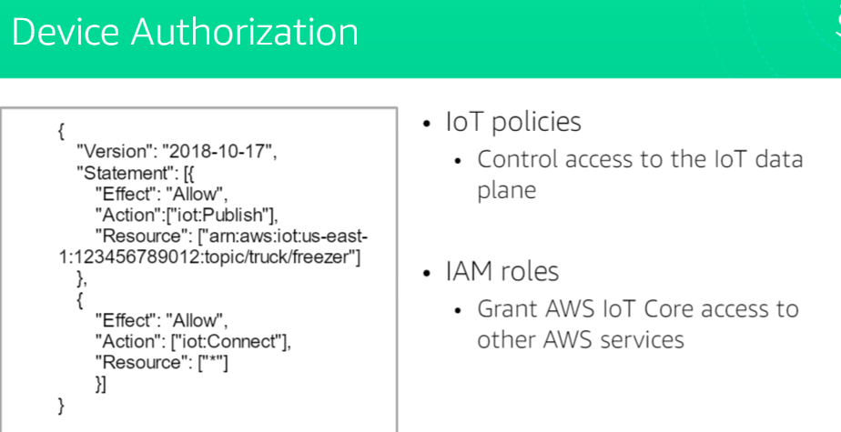

\***Applying security to The Thing that was created by us above.**

Go to IoT core->click on secure->Policy->Edit Policy Document(Make changes as required)

Example below:

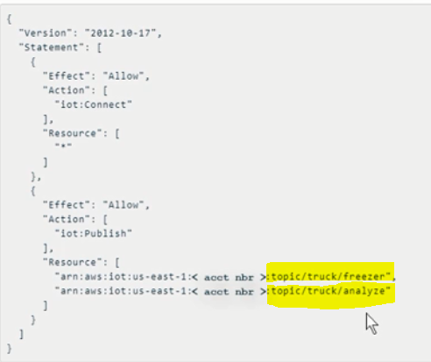

After the changes have been made, You have to install the same certificated on the device.

**Introduction to MQTT(Message Queueing Telemetry Transport)**

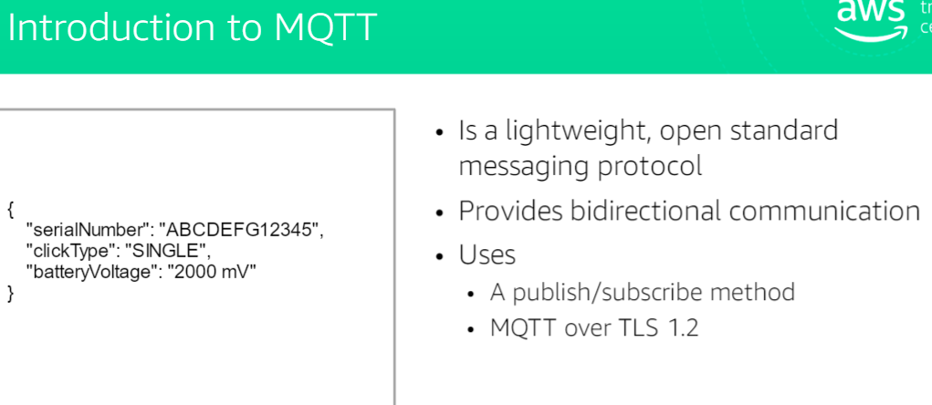

**Introduction to IoT Registry**

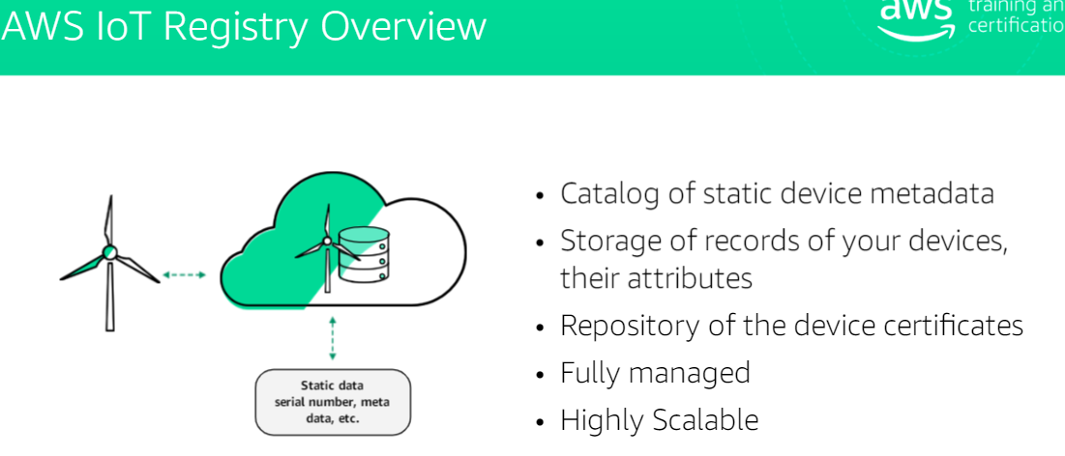

**Testing the communication**:

Click on Test-> set subscription topic name-> you can see the communication happening below.

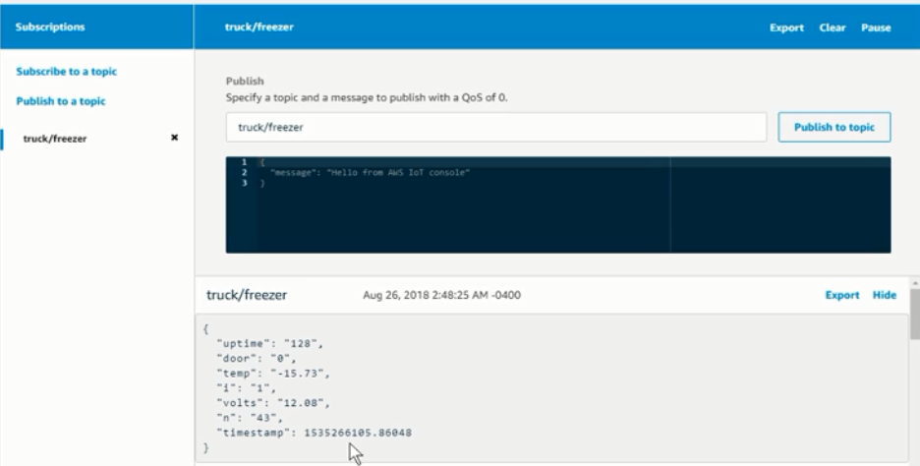

**AWS IoT Rules Engine:**

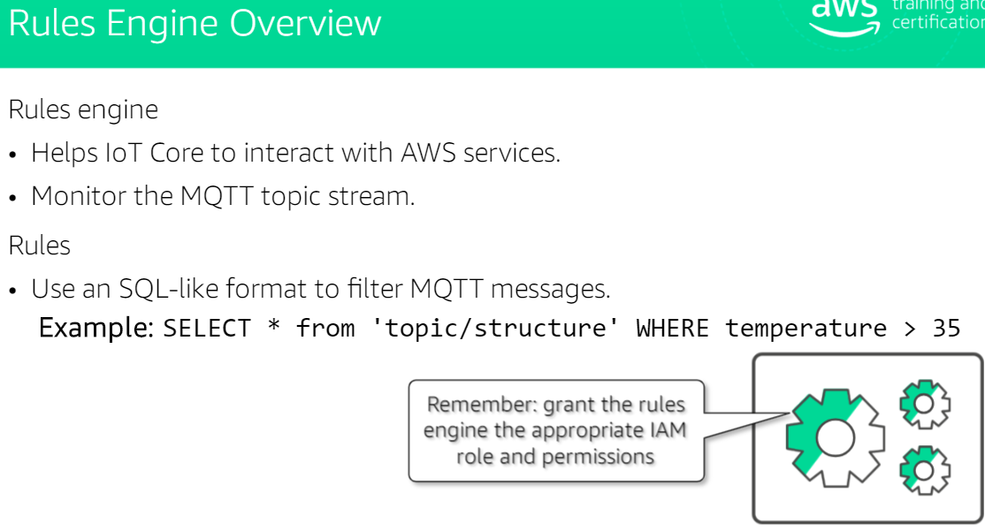

**Applying Rules on our Problem:**

Click Act(Rules)->Name/Describe it->attribute(sql query of what you want)->topic filter->add action->Republish msgs to an AWS IoT topic->create new topic(Truck analyze)->create a new IAM role->again add action->send it to IoT analytics channel->create a IAM role. (Test all of it)

* What we are doing is we are taking the truck data and analyzing it. It is all being done from MQTT client within IoT core AWS account.

**Analyzing the data:**

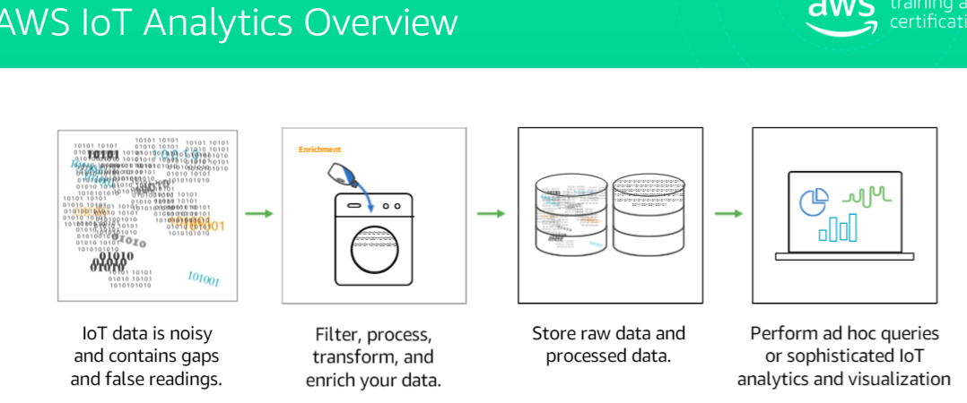

**Presenting the data(with AWS Quicksight)**

Service->create a pipeline->pipeline ID->select the attributes->create Datastore->create data set->(Click on analyze->create sql->ID->source[Datastore created]->set frequency).

After this

Go to quicksight->create a new ID and start visualizing the data from the data set created.IT can be visualized as graphs,charts,piechart etc.(you have several options, just have to select the X and Y axis.

For Reference:

